29th Bled eConference
Digital Economy
June 19 - 22, 2016; Bled, Slovenia

Submission Format for Bled eConference:
A Sample Template and Guide for Authors Submission
<1st Author Name>
<Institution>, <Country>
<Email address>
<2nd Author Name>
<Institution>, <Country>
<Email address>

Abstract
The abstract should shortly define the topic of the paper and briefly and clearly summarise the main results and conclusions of the paper. General statements should not be included in the abstract. Please try to keep the length of your abstract to 1000 characters or less. This abstract should appear here and should also be copied into the online submission form.
Keywords: Research Paper, Submission, Template, Bled eConference

Introduction
Please read through this entire document before you start using it as a template to create your research paper. This will save you and us, the Technical Committee, considerable time, and improve your chances for acceptance as reviewers can not help but noticing paper’s design. The following information is provided to help you prepare the Final Paper Submission to Bled eConference.
Authors should remember that:
Research papers addressing one of the conference research topics should be original, unpublished elsewhere and no longer than 5,000 words. Papers should be submitted in .doc or .rtf format. We suggest that the text of the submitted papers is proofread by a language editor, English native speaker.
All papers will be reviewed by two referees. Based on the recommendations of the reviewers, the Research Track Chair accepts the paper; demands minor or major changes, or rejects the paper.

Overview of the Final Paper format
We request that you follow these guidelines as closely as possible so that the Bled eConference Proceedings will have a professional look.
All paragraphs of text, including the abstract, figure captions, and references, should be justified at the left and the right edges.
The Title of the paper should be 16-point Arial font. Its paragraph description should be set so that the line spacing is single with 18-point spacing before and 12-point spacing after (Paragraph > Indents and Spacing). If paper has a subtitle, use 15-point Arial Italic font. Please use Headline Style Capitalization.
The font description for Authors should be 12-point Arial Bold and for Institutions and Email Addresses should be 11-point Arial. The paragraph description should be set so that the line spacing is single with 6-point spacing after. Use an additional line spacing of 12 points before the beginning of Abstract, as shown above.
Paper Headers should be in 11 point Calibri (Body) Italic aligned to right edge and separated from paper text with a single thin line. Header content differs for odd and even pages. Odd pages indicate first and last names of the authors separated by commas. Headers of even pages indicate the paper title. If necessary the title should be appropriately shortened to fit in a single line. There is no header on the first page.
Footer’s font formatting is the same as of the Header. There is no separating line. Footer information consists solely of the page number in the right corner. Pages should be numbered consecutively.

Detailed Text Formatting
Using A4 21x29.7-cm paper, the top margin is 2.5 cm, the bottom and side margins are each 3 cm.
Each major section begins with a Heading in 16 point Calibri (Body) font. Section headings are numbered except for Acknowledgement and References. The paragraph description of the section heading line should be set for 12 points before, 3 points after, and the line spacing should be set to exactly 16 points.
For the body of your paper use 12-point Calibri (Body) font and set your line spacing at “exactly 12 points” with 0 points before and 6 points after.
Further details are provided in the remainder of this paper for specific situations.

Mayor Subsections
As shown, denote subsections with left justified 14-point Calibri (Body) Bold. Follow the numeral designation (no period) with a single space and then the subsection title capitalizing the first letter of each word. The paragraph description of the subsection heading is set to “exactly 12-point” line spacing with 0 points before and 6 points after.

Authors’ Information
Pages of the final submission should be formatted as shown in this template and on Figure 1.
Please note that first submissions will undergo a double blind review and therefore must not contain any author information. Please be sure to leave out the author information on the first page as well on the header and in the document background. However when filling out the online submission form state all authors to avoid any unnecessary complications during the reviewer assignment process.
Authors of accepted papers will be asked to submit a final version of the paper which will then need to include authors’ information as shown in this template and in Figure 1 below as well as any other changes that may be required by the reviewers and/or Research Track Chair.
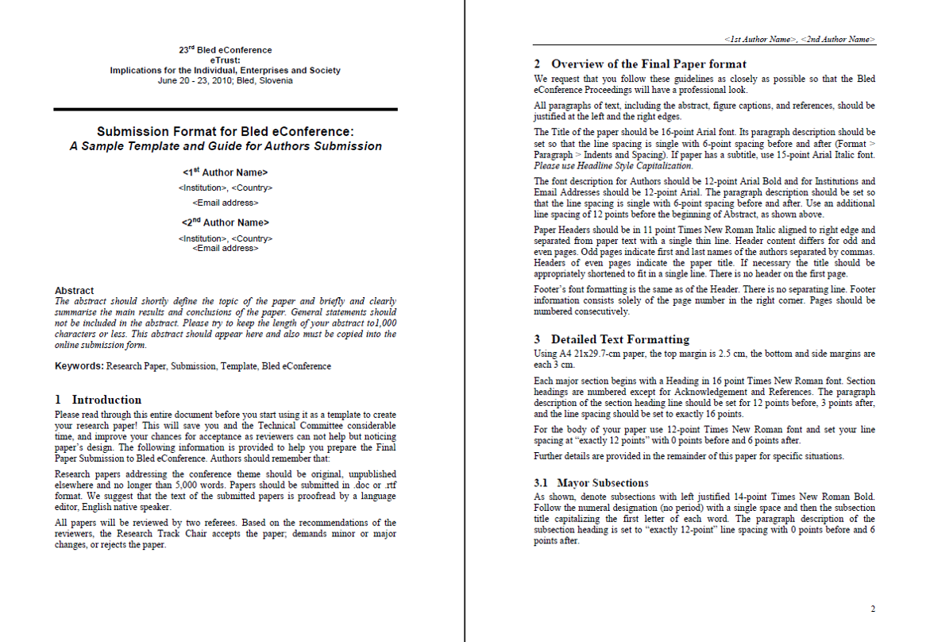
Figure 1: Page formats

Figures and Tables
Figures should utilize as much space within the left and right margins as possible in order to maximize legibility. Use a sans serif font, as Helvetica or Arial, which are much easier to read than Times New Roman. Figures and tables should be consecutively numbered (Figure 1, Figure 2… Table 1, Table 2…) and specifically referred to in the text. Place figure captions directly below each figure. Use 11-point Calibri (Body) with the paragraph spacing set at “exactly 11 points” and line spacing 6 points after. Note that figure captions are always justified left and right, rather than centred, even if they are less than a single full line in length. See captions for Figure 1.

Citing Previous Work<Title of sub section>
References in the text are indicated by the author’s name and year of publication in parentheses. If a referenced paper has four or more authors the reference should appear as the first author followed by et al. The complete bibliographical data must be listed alphabetically at the end of the paper. Journal titles can be abbreviated. All references must be specifically referred in the text; the list of literature should not include references that are not mentioned in the text. Reference list must conform to the APA style. See the References at the end of this template.

Conclusion<Title of section>
Please read these instructions carefully. Following them will improve the quality of your paper and the Proceedings. Table 1 summarizes some of the detail provided.
 | Font | Font Size | Alignment | Paragraph Spacing
 |  |  |  | Before | After
<Title> | Arial Bold | 16 | Centred | 18 pt | 12 pt / 0 pt
<Subtitle> | Arial Bold Italic | 15 | Centred | 0 pt | 12 pt
<Author Name> | Arial Bold | 12 | Centred | 6 pt | 6 pt
<Institution, Country> | Arial | 11 | Centred | 0 pt | 0 pt
<Email Address> | Arial | 11 | Centred | 0 pt | 6 pt
Abstract | Arial Bold | 12 | Justified | 12 pt | 0 pt
<Abstract Text> | Calibri (Body)  Italic | 12 | Justified | 0 pt | 12 pt
Keywords: | Calibri (Body)  Bold | 12 | Justified | 0 pt | 0 pt
<Keyword> | Calibri (Body) | 12 | Justified | 0 pt | 0 pt
<Section Title> | Calibri (Body)  Bold | 16 | Justified, Numbered | 12 pt | 3 pt
<Subsection Title> | Calibri (Body)  Bold | 14 | Justified, Numbered | 12 pt | 3 pt
<Text> | Calibri (Body) | 12 | Justified | 0 pt | 6 pt
Table X: / Figure X: | Calibri (Body)  Bold | 11 | Justified | 0 pt | 6 pt
<Table title/Figure title> | Calibri (Body) | 11 | Justified | 0 pt | 6 pt
References | Arial Bold | 12 | Justified | 12 pt | 0 pt
<References Body> | Calibri (Body) | 12 | Justified | 0 pt | 6 pt
<Footnote Number> | Calibri (Body) | 10 | Superscript | - | -
<Footnote> | Calibri (Body) | 10 | Justified | 0 pt | 0 pt
Table 1: Submission Format Summary
Acknowledgement
The authors wish to acknowledge the Call For Papers at http://callforpaper.com.au and journal Organizacija (http://organizacija.fov.uni-mb.si) for showing good examples on how to prepare Authors Guide and Paper template.
References
- Books
Author. (Year of publication). Book title. Place of publication: Publisher.
Author1, Author2 & Author3. (Year of publication). Book title. Place of publication: Publisher.
Author(s) of chapter. (Year of publication). Chapter title. In Editors of the book (Eds.), Book title (Chapter page range). Place of publication: Publisher.
- Proceedings from conferences
Author(s). (Year of publication). Title. In Conference name, Date (Page range). Place of publication: Publisher.
- eBooks
Author(s). (Year of publication). Title. Publisher. Retrieving date, http address. DOI .
- Thesis
Author(s). (Year of publication). Title. Information, Place of publication.
- Reports
Author(s). (Year of publication). Title. Place of publication: Publisher. (Report number)
- Government publications
Institution name. (Year of publication). Title. Place of publication: Publisher.
- Journal Articles
Author. (Year of publication). Article title. Journal Title. Volume (issue), range of pages. DOI.
Author1, Author2 & Author3. (Year of publication). Article title. Journal Title. Volume (issue), range of pages. DOI.
Author(s). (Year of publication). Article title [Electronic version]. Journal Title. Volume (issue), range of pages. Retrieved date of access, from name of database. DOI.
- Newspaper articles (no author)
Article title. (Publication date). Journal Title. page.
- Encyclopedia articles
Author. (Year of publication). Article title. In Encyclopedia title (volume number, pages). Place of publication: Encyclopedia name.
- Web pages
Author/Sponsor. (last update or copyright date). Title. Retrieved date of access, from URL.
- Lecture notes
Author(s). (Date of presentation). Lecture title. Lecture notes distributed in the unit, at the name of the teaching organisation, the location.
- Standards
Issue body. (Year). Standard name. Standard number. The location.

All Microsoft Office documents (including Supplementary Files) have been saved by going to File and selecting Save As; clicking Tools (or Options in a Mac); clicking Security; selecting "Remove personal information from file properties on save"; clicking Save.
Please write for each author.
Abstract should be in a single paragraph.
Same format applies to Acknowledgement.
Indent each following line of individual reference by 1 cm. Space after paragraph should be 6 points.

