Submission Format for Bled eConference:
A Sample Template and Guide for Authors Submission

Name Surname, Name Surname & Name Surname

Abstract The abstract should shortly define the topic of the paper and briefly and clearly summarise the main results and conclusions of the paper. General statements should not be included in the abstract. Please try to keep the length of your abstract to 1000 characters or less. This abstract should appear here and should also be copied into the online submission form.

Keywords: • Research Paper • Submission • Template • Bled eConference •

Correspondence Address: 1st Author Name Surname, Ph.D., Position, University, Faculty, Faculty Address, Country, e-mail: name.surname@mail.com. 2nd Author Name Surname, Ph.D., Position, University, Faculty, Faculty Address, Country, e-mail: name.surname@mail.com. 3rd Author Name Surname, Ph.D., Position, University, Faculty, Faculty Address, Country, e-mail: name.surname@mail.com.

1 Introduction

Please read through this entire document before you start using it as a template to create your research paper. This will save you and us, the Technical Committee, considerable time, and improve your chances for acceptance as reviewers can not help but noticing paper’s design. The following information is provided to help you prepare the Final Paper Submission to Bled eConference.
Authors should remember that:
Research papers addressing one of the conference research topics should be original, unpublished elsewhere and no longer than 5,000 words. Papers should be submitted in .doc or .rtf format. We suggest that the text of the submitted papers is proofread by a language editor, English native speaker.
All papers will be reviewed by two referees. Based on the recommendations of the reviewers, the Research Track Chair accepts the paper; demands minor or major changes, or rejects the paper.

2 Overview of the Final Paper Format

We request that you follow these guidelines as closely as possible so that the Bled eConference Proceedings will have a professional look.
All paragraphs of text, including the abstract, figure captions, and references, should be justified at the left and the right edges.
The Title of the paper should be 14-point Times New Roman font. Its paragraph description should be set so that the alignment is centered and the line spacing is single with 0 points spacing before and after (Paragraph > Indents and Spacing). Please use Headline Style Capitalization.
The font description for Authors should be 12-point Times New Roman in uppercase. The paragraph description should be set so that the line spacing is single with 0 points spacing before and after. Use an additional single line spacing before the beginning of Abstract, as shown above.
Please use Author data Style to list correspondence address data for all authors. Correspondence address should be listed as 9-point Times New Roman font above 1st page footer.
Paper Headers should be in 9-point Times New Roman. Header alignment differs; right for odd and left for even pages. Header content consists of page number and text. Page numbering should be in the upper right corner for odd and upper left corner for even pages. Pages should be numbered consecutively. Thin vertical line should be separating page number from the rest of the header content. Content should indicate the paper title in capital letters first and last names of the authors separated by commas.
Footer’s font formatting should be 8-point Times New Roman with a separating line. Footer information consists solely of the footnote references.

3 Detailed Text Formatting

Using custom size 17x23-cm paper, the top margin is 1,95 cm, the bottom and outside margins are each 1,23 cm and inside margin is 2,5 cm. Use mirror margins.
Each major section begins with a Heading in bold 10-point Times New Roman font. Section headings are numbered except for Acknowledgement and References. The paragraph description of the section heading should be set for the single line spacing with 0 points spacing before and after. For separating the heading and the text one additional line should be used.
For the body of your paper use 10-point Times New Roman font and set your line spacing at 0 points with 0 points before and after.
Further details are provided in the remainder of this paper for specific situations.

3.1 Mayor Subsections

As shown, denote subsections with left justified 10-point Times New Roman Bold. Follow the numeral designation (no period) with a single space and then the subsection title capitalizing the first letter of each word. The paragraph description of the subsection heading is set to single line spacing with 0 points before and after.

3.2 Authors’ Information

Pages of the final submission should be formatted as shown in this template and on Figure 1.
Please note that first submissions will undergo a double blind review and therefore must not contain any author information. Please be sure to leave out the author information on the first page as well on the header and in the document background. However when filling out the online submission form state all authors to avoid any unnecessary complications during the reviewer assignment process.
Authors of accepted papers will be asked to submit a final version of the paper which will then need to include authors’ information as shown in this template and in Figure 1 below as well as any other changes that may be required by the reviewers and/or Research Track Chair.
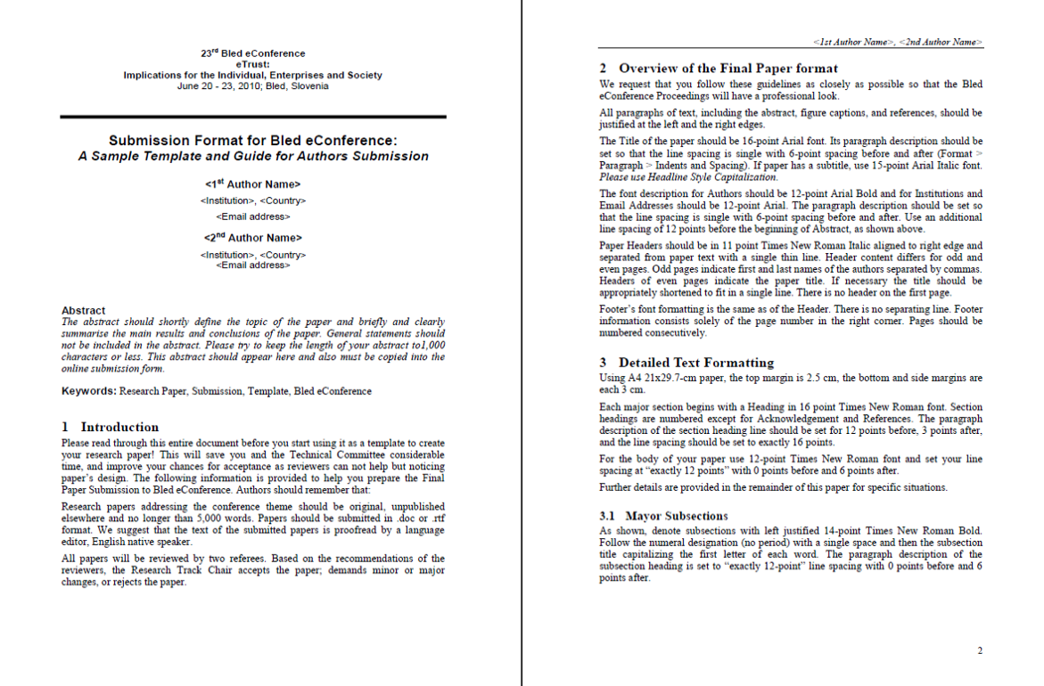
Figure 1: Page formats

3.3 Figures and Tables

Figures should utilize as much space within the left and right margins as possible in order to maximize legibility. Use a sans serif font, as Helvetica or Arial, which are much easier to read than Times New Roman. Figures and tables should be consecutively numbered (Figure 1, Figure 2… Table 1, Table 2…) and specifically referred to in the text. Place figure captions directly below each figure. Use 10-point Times New Roman with the paragraph spacing set at 0 points and line spacing 0 points before and after. Note that figure captions are always justified centred. See captions for Figure 1.

3.4 Citing Previous Work<Title of sub section>

References in the text are indicated by the author’s name and year of publication in parentheses. If a referenced paper has four or more authors the reference should appear as the first author followed by et al. The complete bibliographical data must be listed alphabetically at the end of the paper. Journal titles can be abbreviated. All references must be specifically referred in the text; the list of literature should not include references that are not mentioned in the text. Reference list must conform to the APA style. See the References at the end of this template.

4 Conclusion<Title of section>

Please read these instructions carefully. Following them will improve the quality of your paper and the Proceedings. Table 1 summarizes some of the detail provided.

 | Font | Font Size | Alignment
<Title> | Times New Roman Bold | 14 | Centred
<Subtitle> | Times New Roman Bold | 14 | Centred
<Authors> | Times New Roman UPPERCASE | 12 | Centred
Abstract | Times New Roman Bold | 10 | Justified
<Abstract Text> | Times New Roman | 10 | Justified
Keywords: | Times New Roman Bold | 10 | Justified
<Keyword> | Times New Roman | 10 | Justified
<Section Title> | Times New Roman Bold | 10 | Justified, Numbered
<Subsection Title> | Times New Roman Bold | 10 | Justified, Numbered
<Text> | Times New Roman | 10 | Justified
Table X: / Figure X: | Times New Roman | 10 | Justified
<Table title/Figure title> | Times New Roman | 11 | Justified
Acknowledgments/References | Times New Roman Bold | 9 | Justified
<References Body> | Times New Roman | 9 | Justified
<Acknowledgments Body> | Times New Roman | 9 | Justified
<Footnote Number> | Times New Roman | 8 | Superscript
<Footnote> | Times New Roman | 9 | Justified
Table 1: Submission Format Summary

Acknowledgments

The authors wish to acknowledge the Call For Papers at http://callforpaper.com.au and journal Organizacija (http://organizacija.fov.uni-mb.si) for showing good examples on how to prepare Authors Guide and Paper template.

References

- Books
Author. (Year of publication). Book title. Place of publication: Publisher.
Author1, Author2 & Author3. (Year of publication). Book title. Place of publication: Publisher.
Author(s) of chapter. (Year of publication). Chapter title. In Editors of the book (Eds.), Book title (Chapter page range). Place of publication: Publisher.

- Proceedings from conferences
Author(s). (Year of publication). Title. In Conference name, Date (Page range). Place of publication: Publisher.

- eBooks
Author(s). (Year of publication). Title. Publisher. Retrieving date, http address. DOI .

- Thesis
Author(s). (Year of publication). Title. Information, Place of publication.

- Reports
Author(s). (Year of publication). Title. Place of publication: Publisher. (Report number)

- Government publications
Institution name. (Year of publication). Title. Place of publication: Publisher.

- Journal Articles
Author. (Year of publication). Article title. Journal Title. Volume (issue), range of pages. DOI.
Author1, Author2 & Author3. (Year of publication). Article title. Journal Title. Volume (issue), range of pages. DOI.
Author(s). (Year of publication). Article title [Electronic version]. Journal Title. Volume (issue), range of pages. Retrieved date of access, from name of database. DOI.

- Newspaper articles (no author)
Article title. (Publication date). Journal Title. page.

- Encyclopedia articles
Author. (Year of publication). Article title. In Encyclopedia title (volume number, pages). Place of publication: Encyclopedia name.

- Web pages
Author/Sponsor. (last update or copyright date). Title. Retrieved date of access, from URL.

- Lecture notes
Author(s). (Date of presentation). Lecture title. Lecture notes distributed in the unit, at the name of the teaching organisation, the location.

- Standards
Issue body. (Year). Standard name. Standard number. The location.

All Microsoft Office documents (including Supplementary Files) have been saved by going to File and selecting Save As; clicking Tools (or Options in a Mac); clicking Security; selecting "Remove personal information from file properties on save"; clicking Save.
Abstract should be in a single paragraph.
Indent each following line of individual reference by 1 cm. Space after paragraph should be 6 points.

